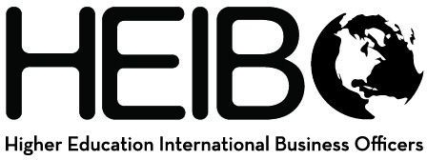

Looking for a professional network for your International Business Managers?

Higher Education International Business Officers (HEIBO) is a new network for finance directors, business managers, financial analysts, and accountants who work with study abroad, international student/scholar services, and international business offices. The focus of the network is on best practices and procedures in our field.

Who are members of HEIBO?
Members include professionals from:
- large and small institutions
- public and private institutions
- study abroad providers

What are the benefits of membership?
- Network of professionals experienced in issues specific to international education
- Responsive and active listserv to answer questions and share current information
- Annual conference held each fall at rotating host institutions
- NEW: website of upcoming events, resources, and best practices: https://heibo.global.umn.edu/
For more info, please contact: Missy Peterson
Director of Finance & Operations
Global Programs and Strategy Alliance University of Minnesota peter329@umn.edu
612-624-3950
https://heibo.global.umn.edu/

